1. **Create a new process by invoking the appropriate system call. Get the process identifier of the currently running process and its respective parent using system calls and display the same using a C program.**

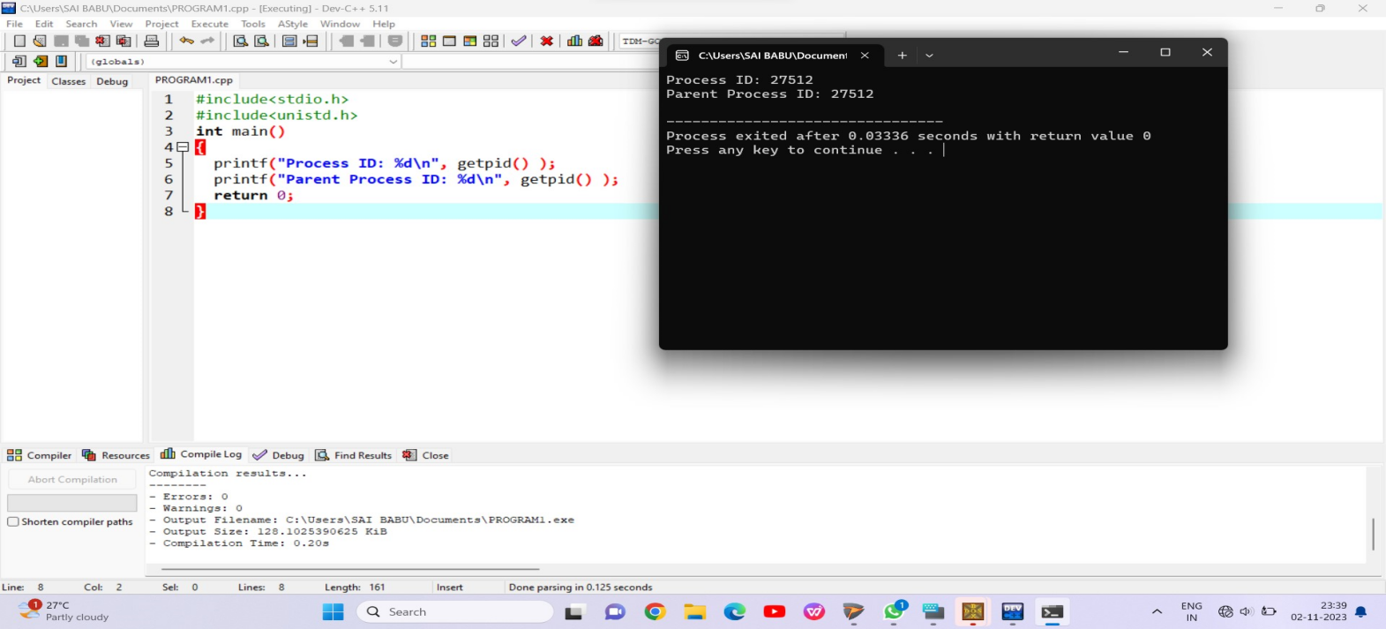

1. **Identify the system calls to copy the content of one file to another and illustrate the same using a C program.**

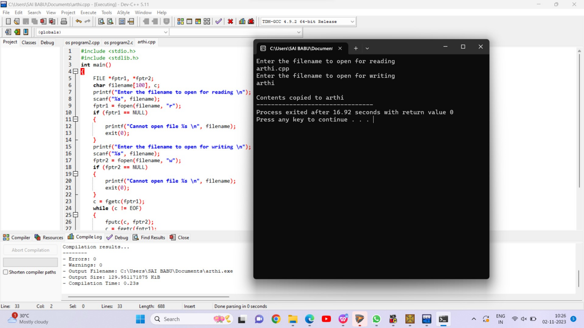

**3. Design a CPU scheduling program with C using First Come First Served technique with the following considerations.**

**a. All processes are activated at time 0.**

**b. Assume that no process waits on I/O devices.**

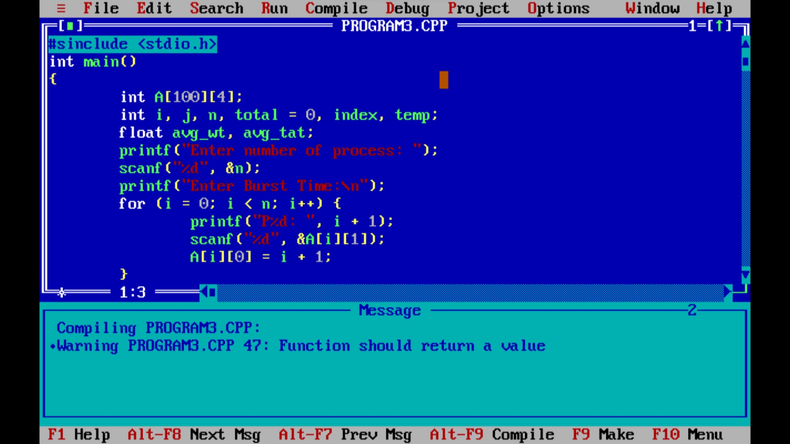

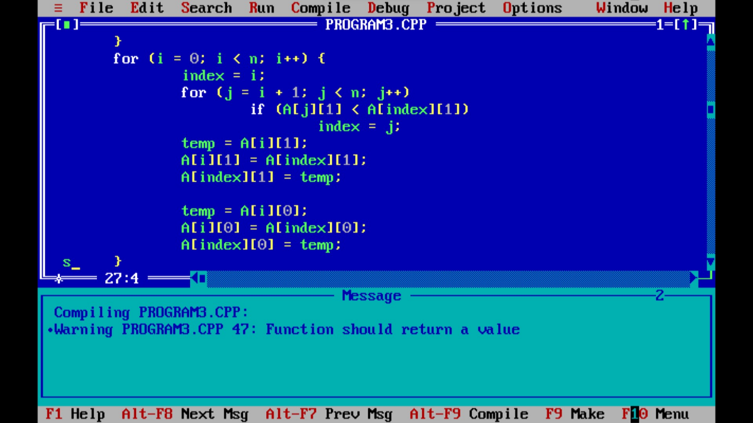

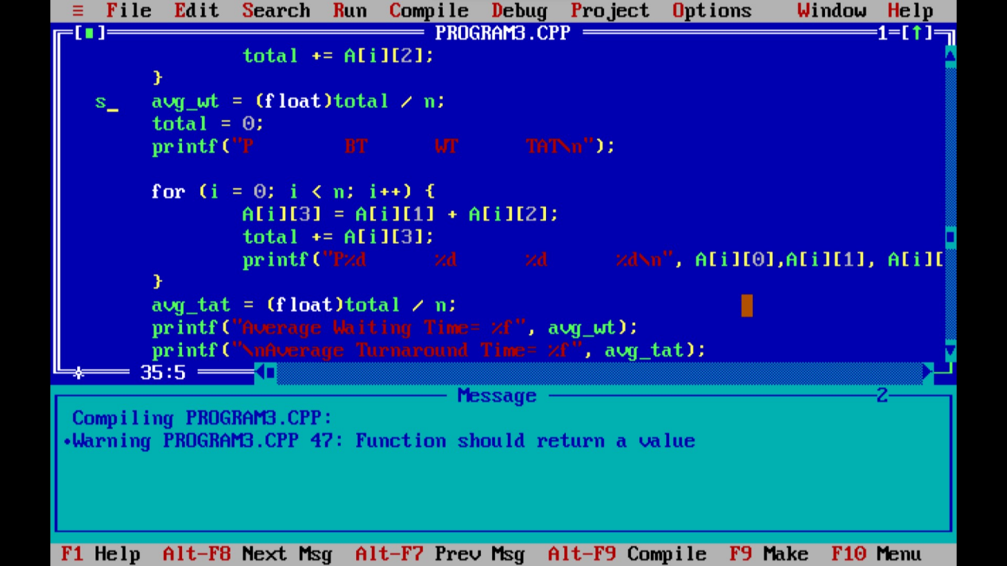

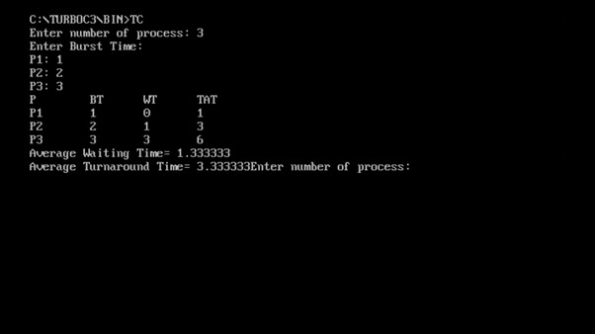

**4. Construct a scheduling program with C that selects the waiting process with the smallest execution time to execute next.**

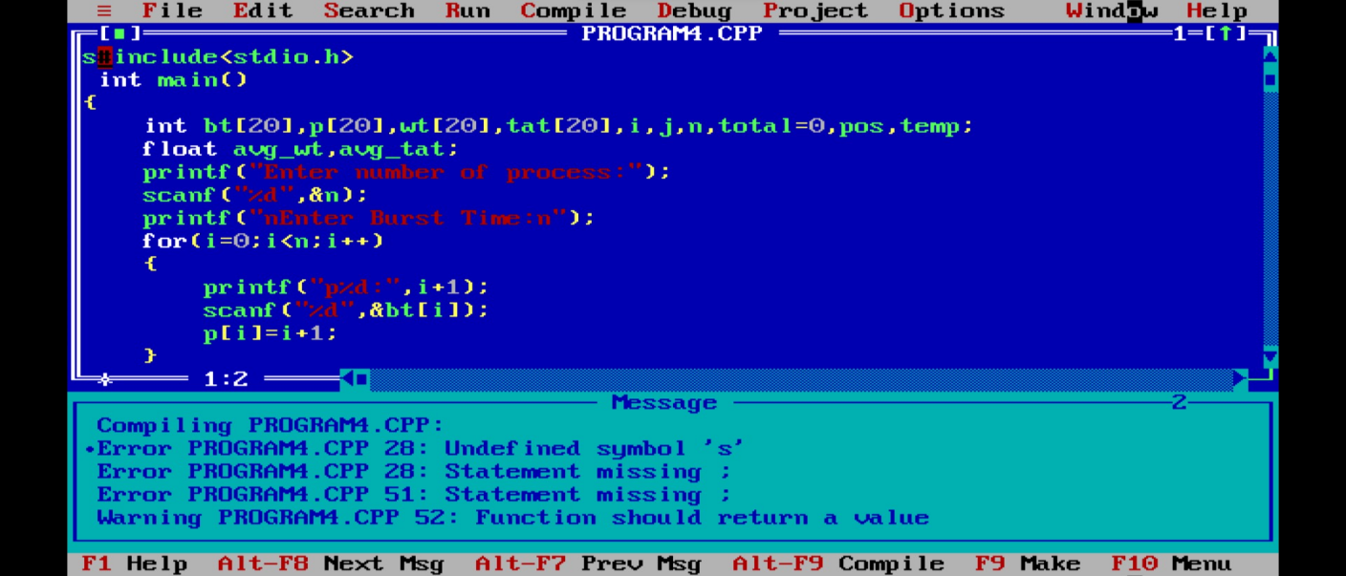

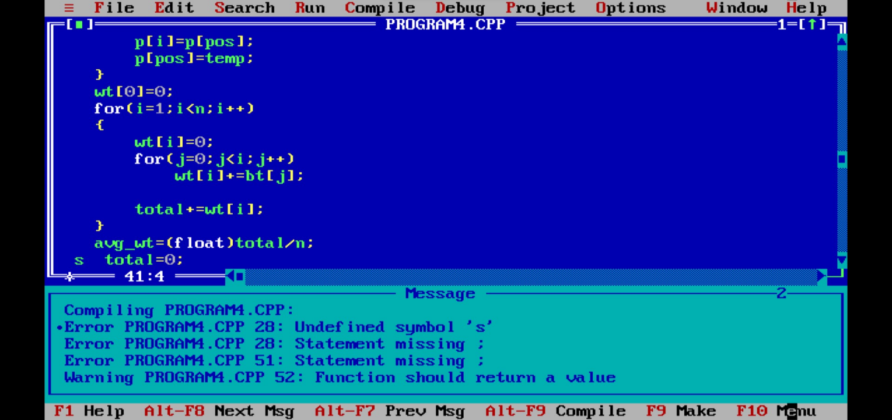

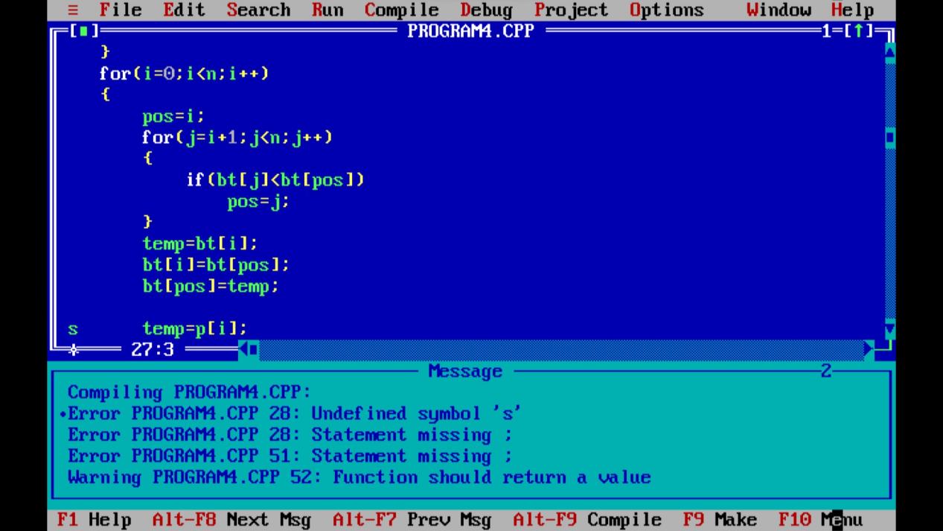

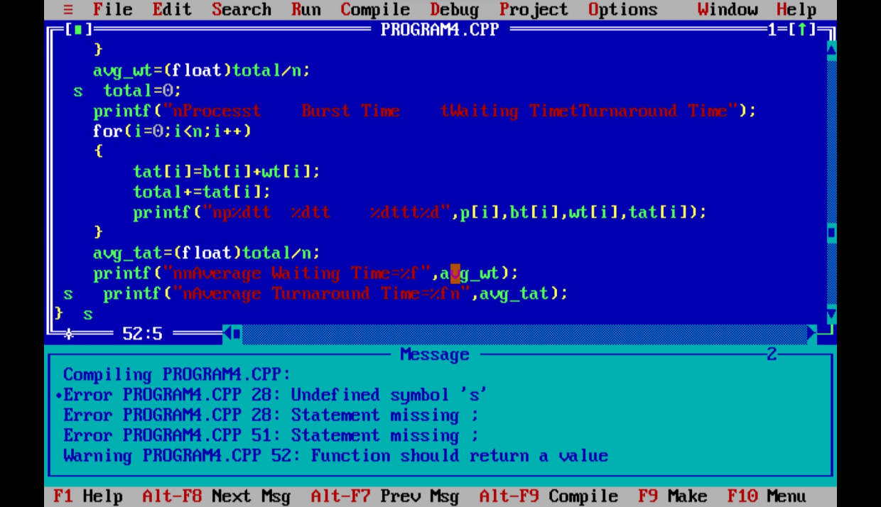

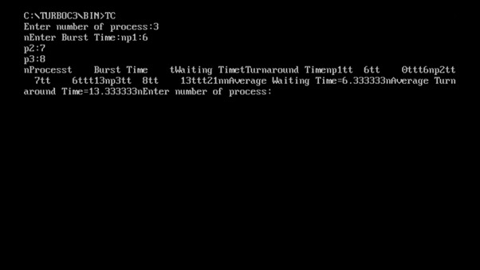

**5. Construct a scheduling program with C that selects the waiting process with the highest priority to execute next.**

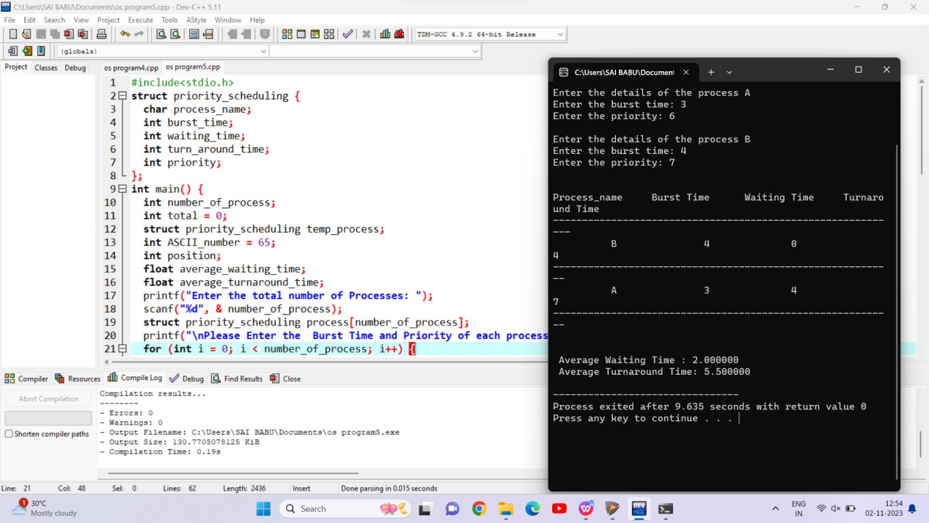

1. **Construct a C program to simulate Round Robin scheduling algorithm**

**with C.**

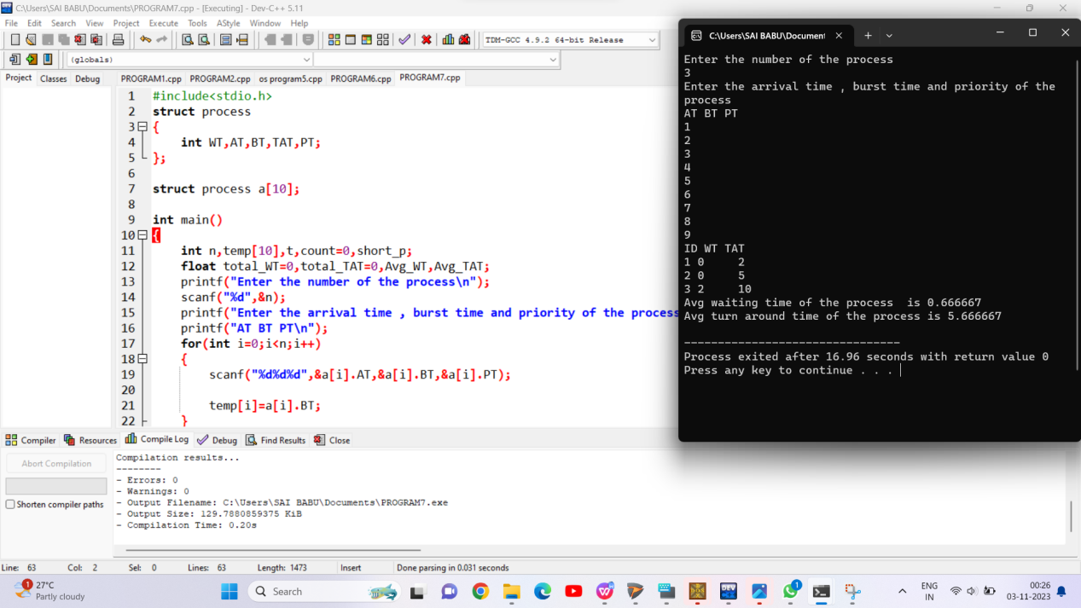

**7. Illustrate the concept of inter-process communication using shared memory with a C program.**

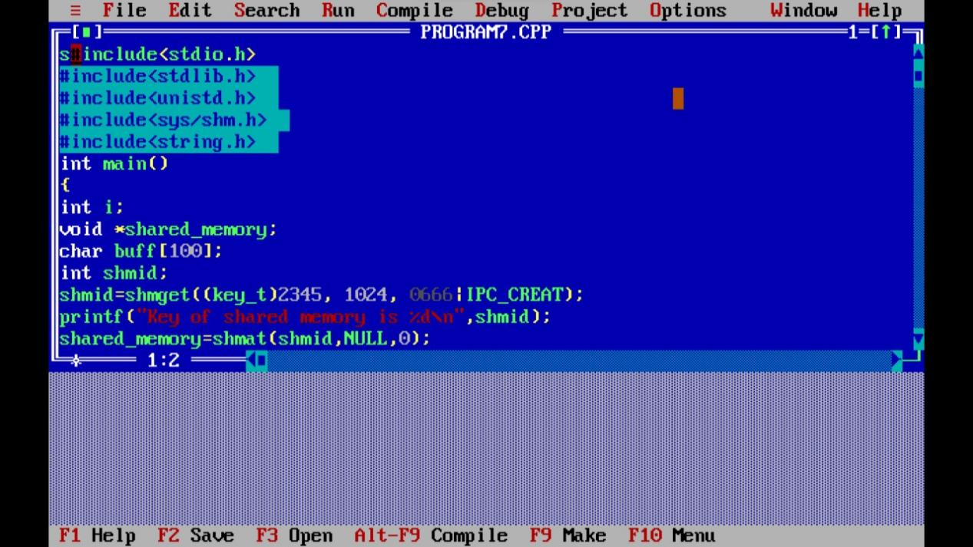

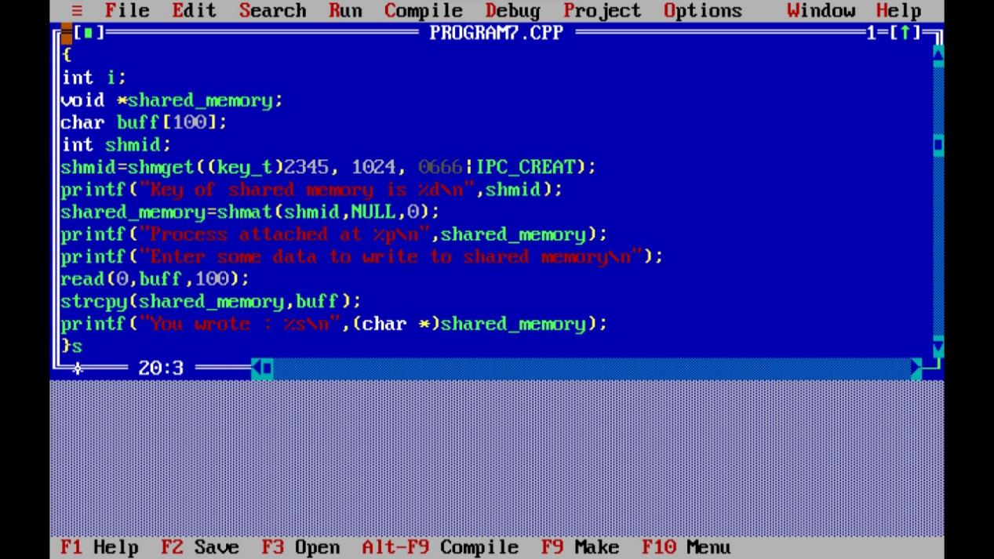

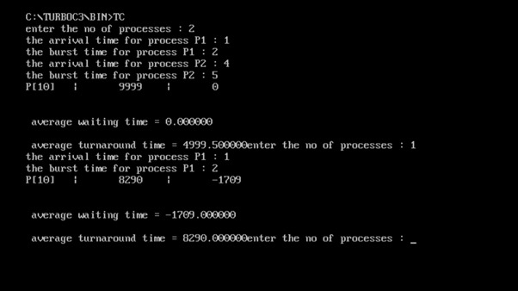

**8.Illustrate the concept of multithreading using a C program**

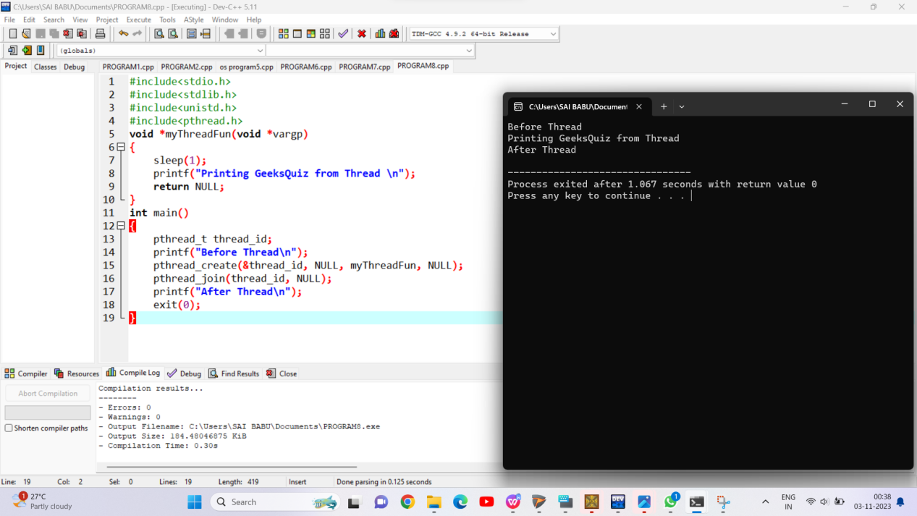

**9.Illustrate the concept of inter-process communication using shared memory with a C program.**

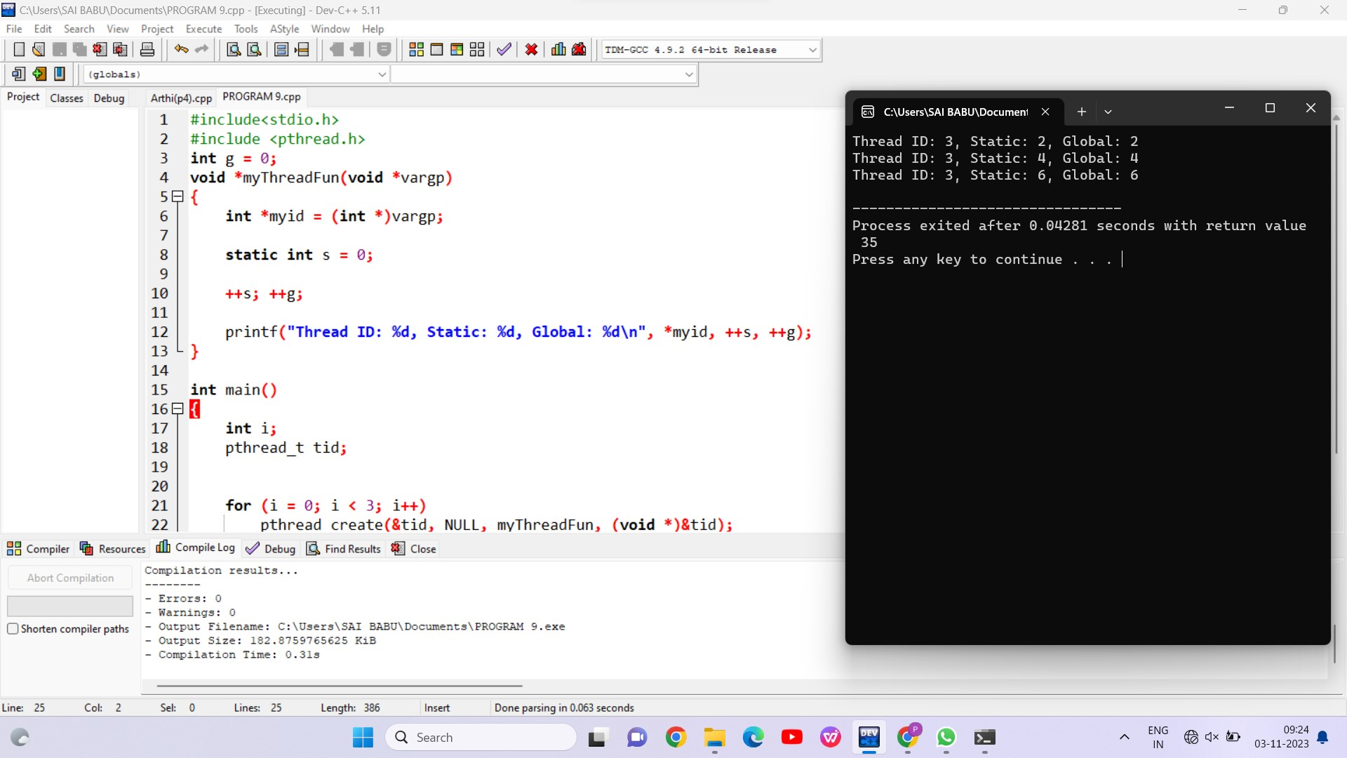

10. Illustrate the concept of inter-process communication using message queue with a C

program.

